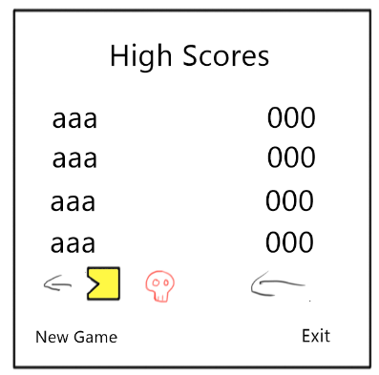

|  |  |
| --- | --- |
| Description | This is the first screen the player sees, it functions both as a leaderboards and a main menu. |
| Sound FX | none |
| Music | happy chip-tune music |
| Camera | fixed |
| Character | Puc-man, Skulls (enemies) chasing each other left and right at the bottom of the screen |
| Transition | If the player clicks on exit, the game closes, if the click on New game, they are sent back the game screen |

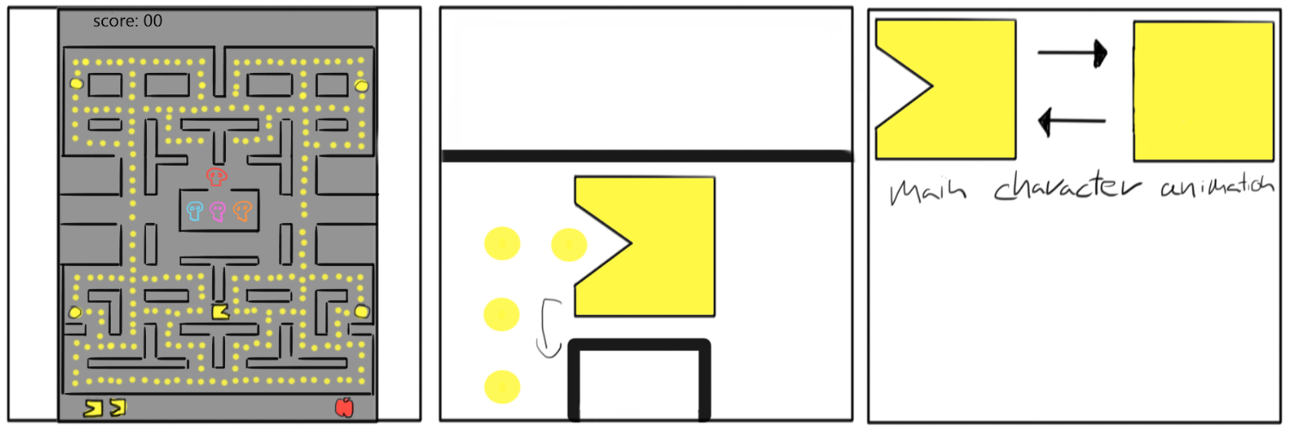

|  |  |
| --- | --- |
| Description | Puc-man is controlled by the player, he moves around and eats dots. The level is complete if puc-man eats all dots on the screen. Meanwhile the 4 enemy skulls follow Puc-man around and try to collide with him. If they manage to, the player loses a life, puc-man is destroyed and respawned at the starting position (as seen on the first image). If the player loses every life, the game is over and the player is sent to the high-score screen. The big dots, or „pills” give the player the ability to eat the skulls for a limited time. Doing this successfully gives extra points. If the level is completed, it is refilled with dots and the game starts again from the starting position. Each dot and enemy eaten will give score to the player, that is displayed at the top of the screen. |
| Sound FX | Puc-man movement sound, big pill pickup sound, on contact with the enemy: death sound |
| Music | none |
| Camera | fixed |
| Character | Puc-man, Skulls (enemies) |
| Transition | if the player loses every life they move on to the high-score screen |